Generative Representation of Aggregate Brain Activity: A Deep Autoencoder Approach for EEG Topoplot Summarization

Tobias Mikha Sulistiyo^{[1]}, Karel Octavianus Bachri^{[2]*}
School of Bioscience, Technology, and Innovation,
Atma Jaya Catholic University of Indonesia, Jakarta, Indonesia^{[1], [2]}
tobias.12024002503@student.atmajya.ac.id^{[1]}, karel.bachri@atmajaya.ac.id ^{[2]}

Abstract—Conventional pixel-wise averaging methods frequently obscure spatial details and fail to isolate baseline artifacts in EEG analysis. This study addresses these limitations by implementing Deep Convolutional Autoencoders (CAEs) to perform data aggregation within the latent space of 2D EEG topoplots. Unlike arithmetic averaging, the model compresses input images into a latent feature space to identify structural invariants. The dataset comprises recordings from adolescents exposed to addiction-related stimuli, stratified into 'Normal/Risk' and 'Fast/Slow' response cohorts. Analysis of the reconstructed images reveals distinct neural mechanisms: normal participants exhibit regulated frontotemporal patterns, whereas the 'Fast/Risk' subset displays global cortical hyperactivation linked to impulsivity. Conversely, 'Slow/Risk' responders show diminished frontal control and dominant posterior (Occipital-Temporal) activation, consistent with the Attentional Bias hypothesis. These findings indicate that the CAE framework effectively suppresses artifacts while preserving signal integrity, providing a superior analytical pathway for neural dynamics in addiction research.
Keywords— Deep Convolutional Autoencoder (CAE), Latent Space Representation, Addiction, Unsupervised Learning, Image Reconstruction.

Introduction
Mapping EEG signals into two-dimensional images is a standard technique to visualize spatial electrical variance and simplify the interpretation of brain states [1], [2]. While effective for individual analysis, applying this format to population-level research introduces significant challenges. The primary difficulty lies in synthesizing data across multiple subjects to generate a representative group model [3]. Data aggregation is critical for identifying spatial configurations that accurately distinguish between experimental conditions [2].
A fundamental limitation in standard aggregation protocols is the reliance on pixel-wise mean computation across image sets [4]. This approach ignores inter-subject variability, often resulting in blurred spatial details and inaccurate group-level depictions. When neural patterns differ spatially between participants, pixel-wise averaging forces these variations into a single output, creating artifacts and misleading portrayals of brain activity.
Deep learning architectures, particularly Convolutional Autoencoders (CAEs), offer a solution to these statistical limitations [5], [6]. Rather than manipulating raw pixels, CAEs encode inputs into a latent feature space. This process extracts structural invariants defining the data's core characteristics. Aggregation performed at this feature level accommodates spatial discrepancies more robustly than pixel-space operations. The decoder then reconstructs a representative image from the combined vectors, capturing the population's shared structural traits [7].
Literature suggests this generative strategy maintains topographic fidelity superior to pixel-wise averaging, especially in datasets with high subject variability. This makes the framework particularly suitable for creating summary visualizations of heterogeneous spatial activation patterns.
The objective of this study is to implement a Deep Convolutional Autoencoder as a two-dimensional visualization method for EEG signals. This approach is further supported by using a dataset capturing adolescents’ brain responses to addiction-related terminology. The present work extends earlier analyses conducted by Wijayanto et al [3], [8]. The research utilizes a dataset of adolescent brain responses to addiction-related terminology. Subjects are stratified into 'Normal' vs. 'At-Risk' groups and further categorized by reaction latency ('Fast' vs. 'Slow'). By deploying this generative framework, the study establishes a refined protocol for visualizing EEG topography and decoding neural signals, offering a distinct methodological advancement over traditional averaging techniques.

Methods

Datasets and Distribution
The analysis draws upon the dataset archived in the Telkom University Dataverse (https://doi.org/10.34820/FK2/GW8JIV) [8]. This repository contains 1D and 2D EEG recordings documenting neural responses to addiction-related terminology. Data acquisition followed the Go/No-Go Association Task (GNAT) paradigm. The sample consists of twelve adolescents, stratified into 'Normal' and 'At-Risk' cohorts. Research focuses on 2D EEG topoplots to synthesize archetypal response patterns for 'Fast' and 'Slow' reaction latencies.
The complete dataset comprises 812 topoplot images. Classification relied on temporal performance: trials with reaction times between 0–0.5 s were labeled 'Fast', while the 0.5–1.0 s interval defined the 'Slow' category. Distribution across cohorts is as follows:
    - Normal Group: 492 images (260 Fast / 232 Slow).
    - At-Risk Group: 320 images (153 Fast / 167 Slow).

Autoencoder Architecture for Latent Space Aggregation
The system architecture utilizes a Deep Convolutional Autoencoder (CAE). This unsupervised framework is optimized for high-dimensional imagery, employing convolutional filters to maintain the spatial hierarchy of input data—a capability lacking in standard fully connected layers [9]. Spatial correlation between neighboring electrodes is critical in EEG topography. Accordingly, the model features a symmetrical dual-pathway design: an encoder for feature extraction and a decoder for image reconstruction. The encoding phase compresses input topoplots through sequential convolutional operations. Equation (1) governs the transformation for each layer:
$$h_{k}=σ(W_{k}* h_{k-1}+ b_{k})$$ | (1)
Here, * denotes the convolution operator $W_{k}$ is the learnable kernel matrix, $b_{k}$ is the bias term, and $h_{k-1}$ is the input feature map [10], [11]. A Max-Pooling layer succeeds each convolutional block to downsample spatial dimensions and establish translational invariance. This process condenses the initial 128 × 128 resolution into a compact 16 × 16 feature abstraction. 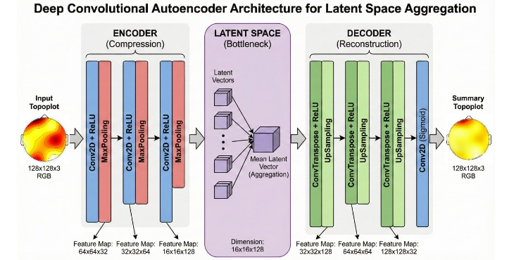
Figure 1. Schematic diagram of the proposed latent space aggregation framework.
Latent Space Aggregation A core methodological innovation is the shift of aggregation to the latent feature domain (Figure 1). Deviating from protocols that average pixel values directly, this framework derives consensus patterns from compressed feature embeddings. Latent-space averaging distills essential structural elements and filters stochastic noise, addressing the artifact susceptibility of high-dimensional pixel data. A preliminary compression phase sanitizes the data before aggregation.
For a specific category (e.g., At-Risk/Fast), the model computes the mean vector using Equation (2):
$$z_{avg}=\frac{1}{N}\sum_{i=1}^{N}{z_{i}}$$ | (2)
N represents the sample count and z_{i} the individual latent vectors [12], [13]. The decoder then reconstructs the final image from this averaged vector z_{avg}, preserving sharp gradient characteristics.

Results and Discussion
  - Normal – Fast Category Respondents
Within the Normal category, the dataset comprises a total of 492 topoplots. These images were stratified based on reaction latencies recorded during the GNAT assessment, yielding 260 instances in the 'fast' category (reaction time < 0.5 s) and 232 in the 'slow' category (reaction time > 0.5 s). This segmentation is supported by prior literature suggesting that rapid responses particularly those under 250 ms are indicative of 'honest' or instinctive processing [14]. Consequently, the application of GNAT provides an optimal framework for isolating authentic neural responses within the analysis.
A. 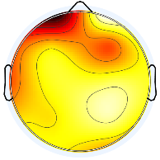B.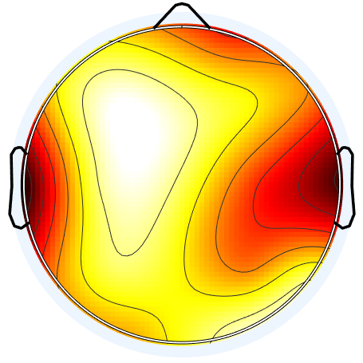C.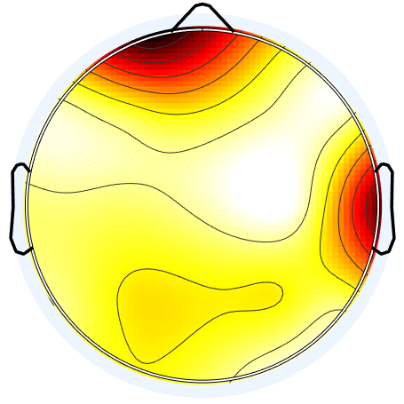
Figure 2. Examples of normal category in fast responses
Figure 2 visualizes the raw topoplots, exposing a marked inconsistency in how different subjects respond. The focal points of neural activity shift unpredictably ranging from localized left frontal activation in Respondent A, to bilateral temporal patterns in Respondent B, and a more diffuse frontal-temporal engagement in Respondent C. These examples illustrate that sharp activation peaks are not a constant feature in raw data. Furthermore, a dark baseline artifact dominates the background of these images. To prevent this non-informative noise from distorting the final aggregate, it must be suppressed before the averaging stage begins.
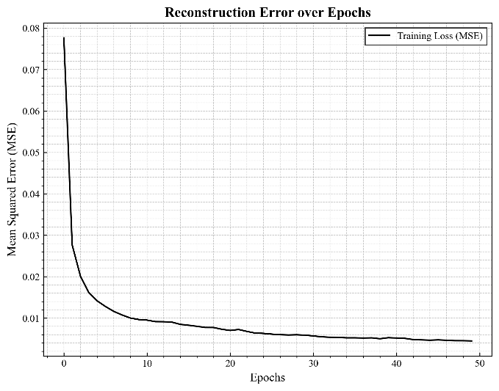
Figure 3. Reconstruction models error over epoch for normal-fast
To achieve high-fidelity image reconstruction, the model relies on the encoder’s ability to map input data into a compressed latent representation. The training stability of this process is plotted in Figure 3, which tracks the error reduction trajectory over time. By the 50th epoch, the model converged successfully, driving the loss value down to below 0.01. This low-error state indicates that the network has effectively learned to isolate meaningful neural features from background noise. Consequently, we applied these trained parameters to the raw dataset to suppress the non-informative dark baseline. The practical impact of this denoising step which clarifies the active neural regions is visually demonstrated across Figures 4, 5, and 6.
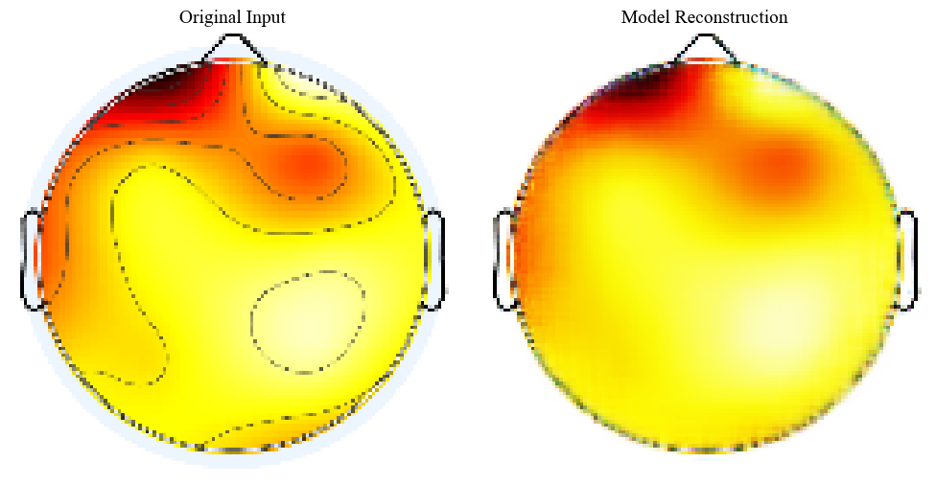
Figure 4. Reconstructed EEG topoplots output for respondent A after baseline removal
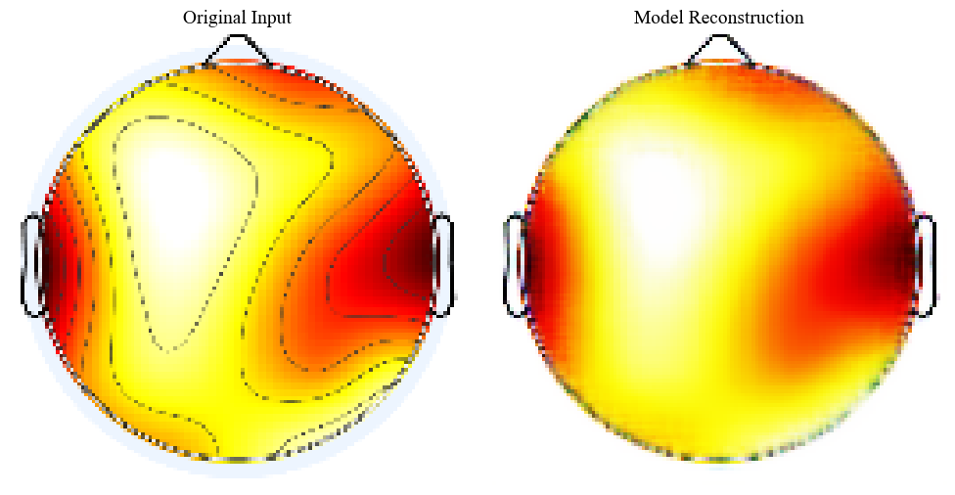
Figure 5. Reconstructed EEG topoplots output for respondent B after baseline removal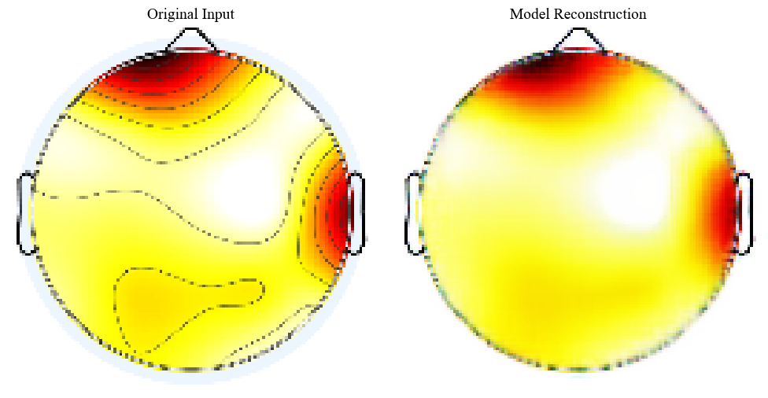
Figure 6. Reconstructed EEG topoplots output for respondent C after baseline removal.
The efficacy of the training process in eliminating baseline artifacts is visually demonstrated in Figures 4 through 6. As observed in these reconstructions, the model successfully isolates regions of genuine neural activity, effectively stripping away the dark background noise. Subsequently, these cleaned topoplots were subjected to an aggregation process. Specifically, for the 'Fast' response category, the averaging was performed not on raw pixels, but within the latent space representation to capture the shared structural features. The final aggregated output resulting from this method is presented in Figure 7.
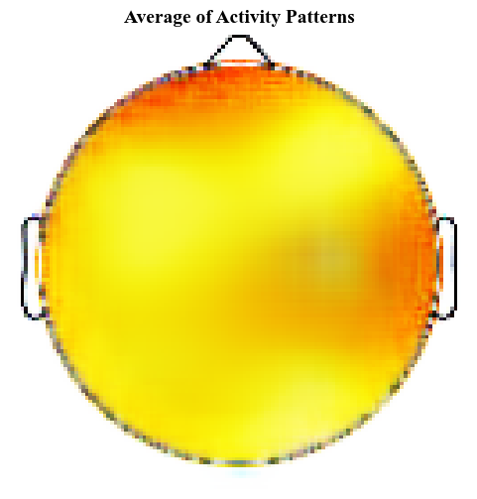
Figure 7. Average of activity patterns in normal-fast category respondent
As shown in Figure 7, the averaged results for the Normal-Fast category display a relatively diffuse neural signal. The activity does not cluster in a single point but spreads across the map in a gradient of yellow and orange. Deep orange tones, representing the highest intensity, dominate the frontal lobe, with moderate activation extending into the temporal sections. This heavy reliance on the frontal cortex implies a state of high focus and readiness to respond [15]. Such a configuration is unsurprising, as the interplay between frontal and temporal networks is a well-documented mechanism in cognitive response tasks [16], [17].
  - Normal – Slow Category Respondents
For the Normal respondents exhibiting slower reaction times (Normal-Slow), the dataset comprises 232 topoplots. This group was processed using the identical generative framework applied to the Fast category to ensure methodological consistency. To capture the diversity of the subjects within this subset, specific samples were selected from the total pool for comparative analysis. These representative instances, which illustrate the varying activation patterns, are displayed in Figure 8.
D.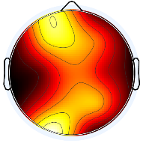E.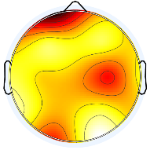F.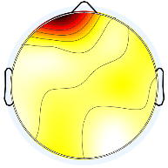
Figure 8. Examples of normal category in slow responses
A closer inspection of the Normal-Slow dataset reveals a marked increase in signal heterogeneity. As illustrated by the three sample variations, neural activity becomes far less uniform when respondents require more time to process addiction-related terminology. It appears that this extended processing window introduces a higher degree of individual variability in how the brain engages with the stimuli, resulting in divergent patterns. Despite this complexity, we proceeded with the training phase using the same autoencoder configuration applied to the Normal-Fast group. The model’s performance in learning these diverse features is tracked in the training loss graph below.

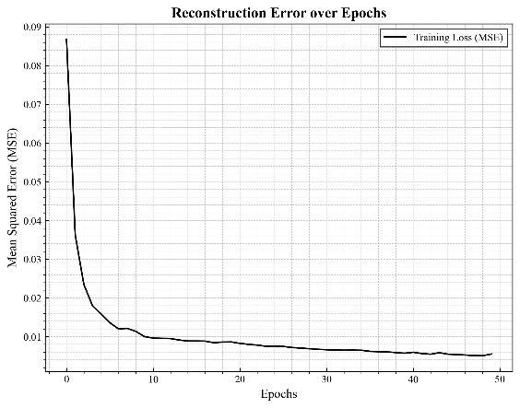
Figure 9. Reconstruction models error over epoch for normal-slow
The training progression, as plotted in Figure 9, demonstrates a consistent downward trajectory in Mean Squared Error (MSE) across all epochs. By the 50th iteration, the model achieved convergence, driving the error rate down to below 0.01. Interestingly, despite the higher variability inherent in this dataset, the loss pattern closely mirrors the stability observed in the Normal-Fast category. This suggests that the autoencoder is robust enough to handle the irregular patterns of slow responders without overfitting. The resulting generative outputs for the Normal-Slow group are presented below.
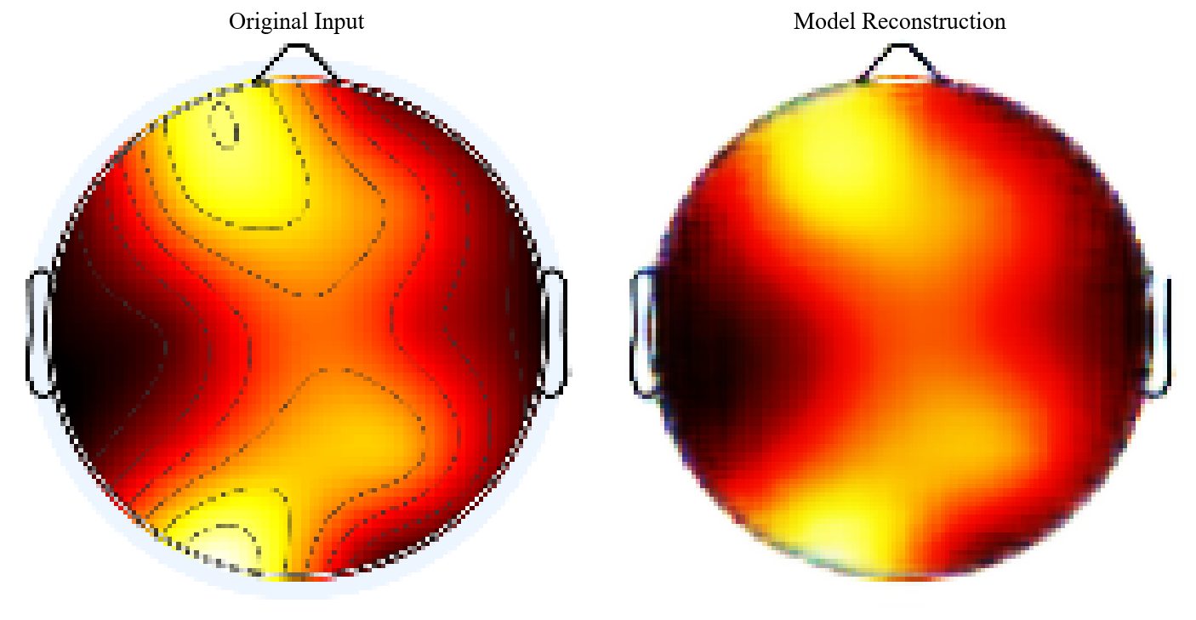
Figure 10. Reconstructed EEG topoplots output for respondent D after baseline removal

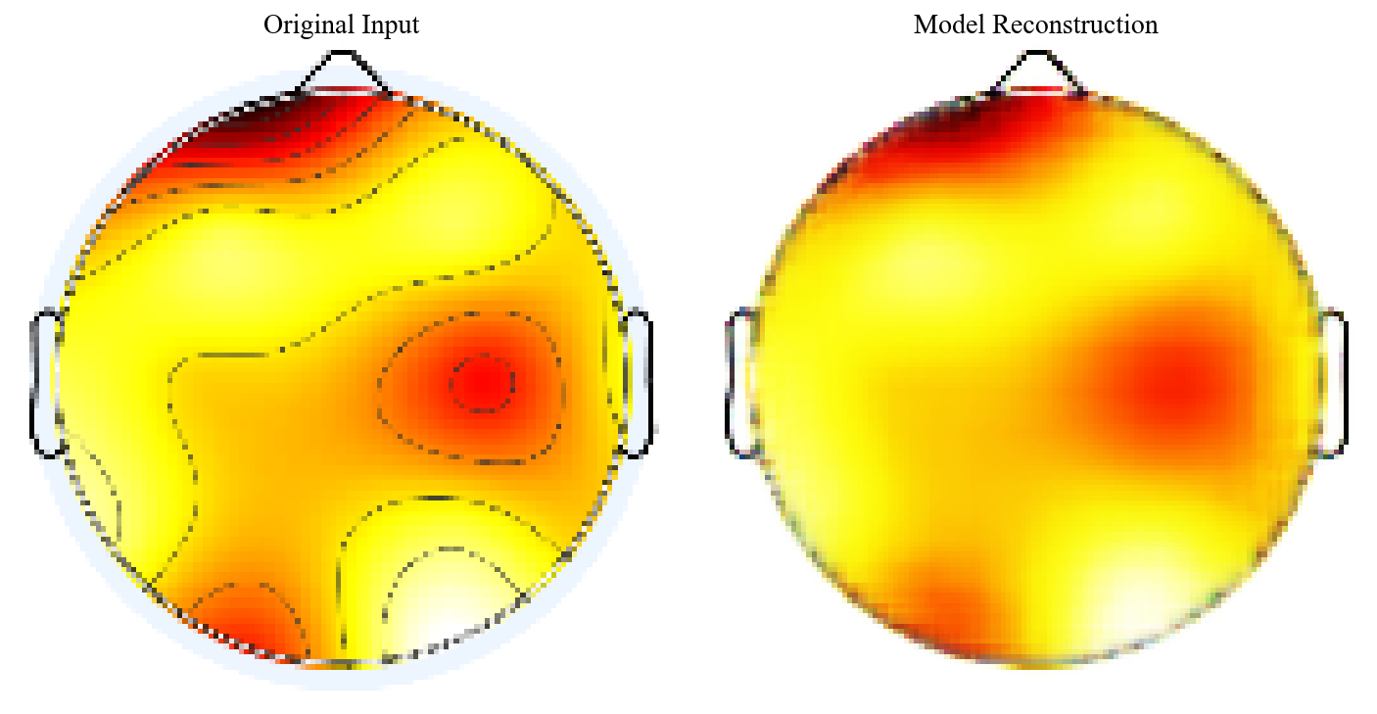
Figure 11. Reconstructed EEG topoplots output for respondent E after baseline removal

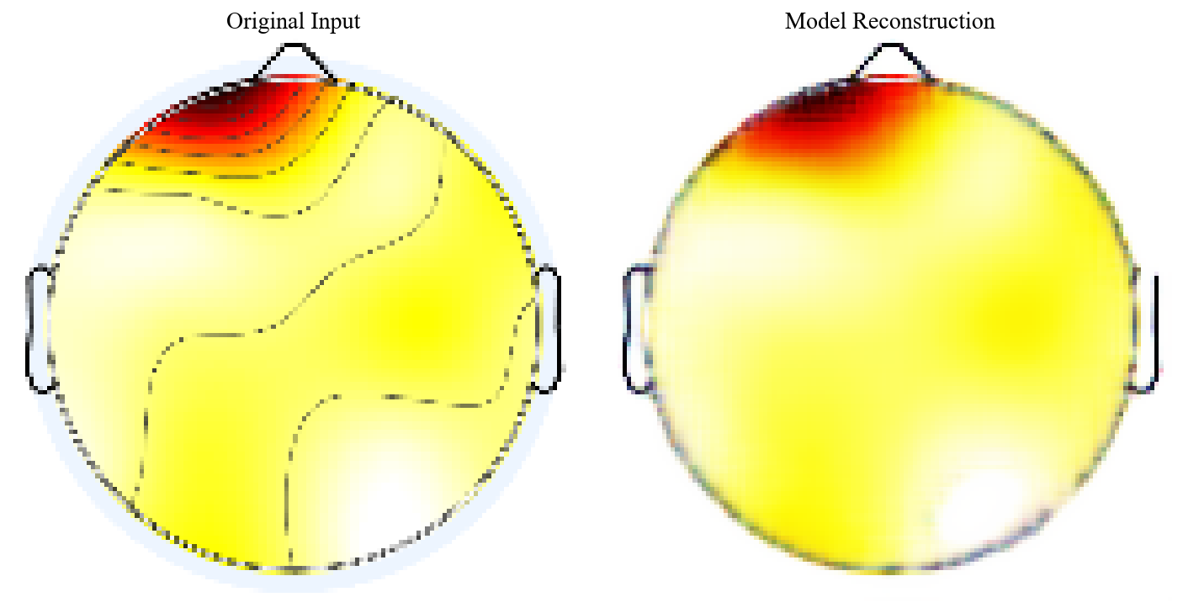
Figure 12. Reconstructed EEG topoplots output for respondent F after baseline removal

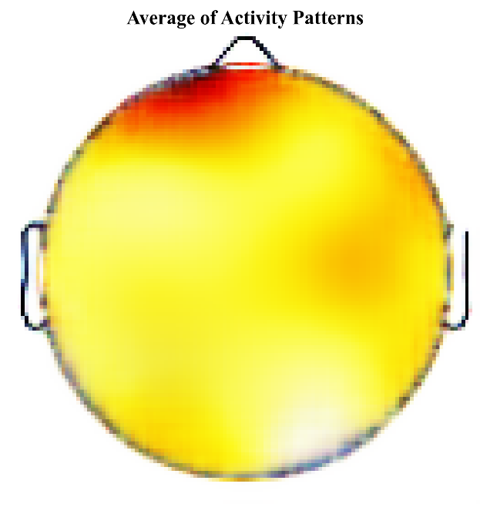
Figure 13. Average of activity patterns in normal-slow category respondent
The averaged topography in Figure 13 reveals a starkly concentrated activation pattern. Unlike the diffuse signals seen in other categories, the neural intensity here is almost exclusively confined to the frontal lobe, while the surrounding regions remain largely quiescent. This pronounced frontal dominance aligns well with established neuroscience literature, which identifies the prefrontal cortex as the central hub for executive functions, working memory, and complex decision-making [18]. The specific context of a 'slow' response offers a compelling interpretation for this localized intensity: it likely represents a cognitive bottleneck where the brain is heavily engaged in deliberating the stimulus. Rather than an immediate impulsive reaction, the high frontal load suggests the subject is actively recruiting executive resources to weigh the options before committing to a correct response.

  - At Risk – Fast Category Respondents
The analytical scope is next extended to the 'At-Risk' cohort, specifically focusing on the subset of respondents exhibiting rapid reaction times. This category, designated as 'At-Risk Fast', consists of a total of 153 EEG topoplot images. In alignment with the protocol established for the Normal group, several raw samples were extracted for preliminary visual inspection and are presented in Figure 14. These representative examples are essential for characterizing the baseline signal patterns, highlighting the inherent spatial variability in the data before the application of any generative processing or noise suppression techniques.
G.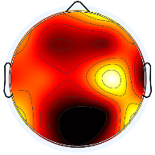H.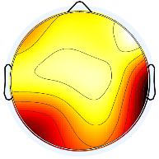I.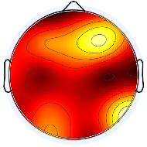
Figure 14. Examples of at-risk category in fast responses
A visual comparison reveals that the neural patterns within the At-Risk Fast category are significantly more chaotic and intensive than those observed in the Normal group. Unlike the focused activity seen previously, the three representative samples here exhibit a pervasive intensity, resulting in topoplots with a noticeably darker overall hue compared to both the Normal-Fast and Normal-Slow datasets. This widespread saturation suggests a heightened state of baseline neural arousal or noise. To address this complexity, the data was subjected to the autoencoder training pipeline. The quantitative performance of this training—specifically its ability to learn these dense features—is evaluated in the loss trajectory graph presented below.
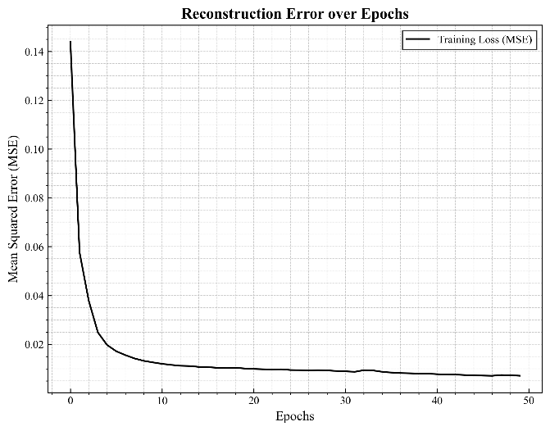
Figure 15. Reconstruction models error over epoch for at-risk fast
The loss trajectory plotted in Figure 15 reveals a consistent minimization of the Mean Squared Error (MSE). By the final epochs, the curve settles below the 0.01 threshold, marking a clear point of convergence. This result is particularly promising given the input's complexity; it confirms that the autoencoder is not merely memorizing noise but effectively disentangling the underlying structure from the chaotic 'Risk-Fast' signals. To validate this performance beyond numerical metrics, the trained model was subsequently engaged to reconstruct the three representative samples selected earlier. This step aimed to visually assess the model's efficacy in stripping away the dominant baseline artifacts while retaining the integrity of the signal patterns, as illustrated in the resulting images below.
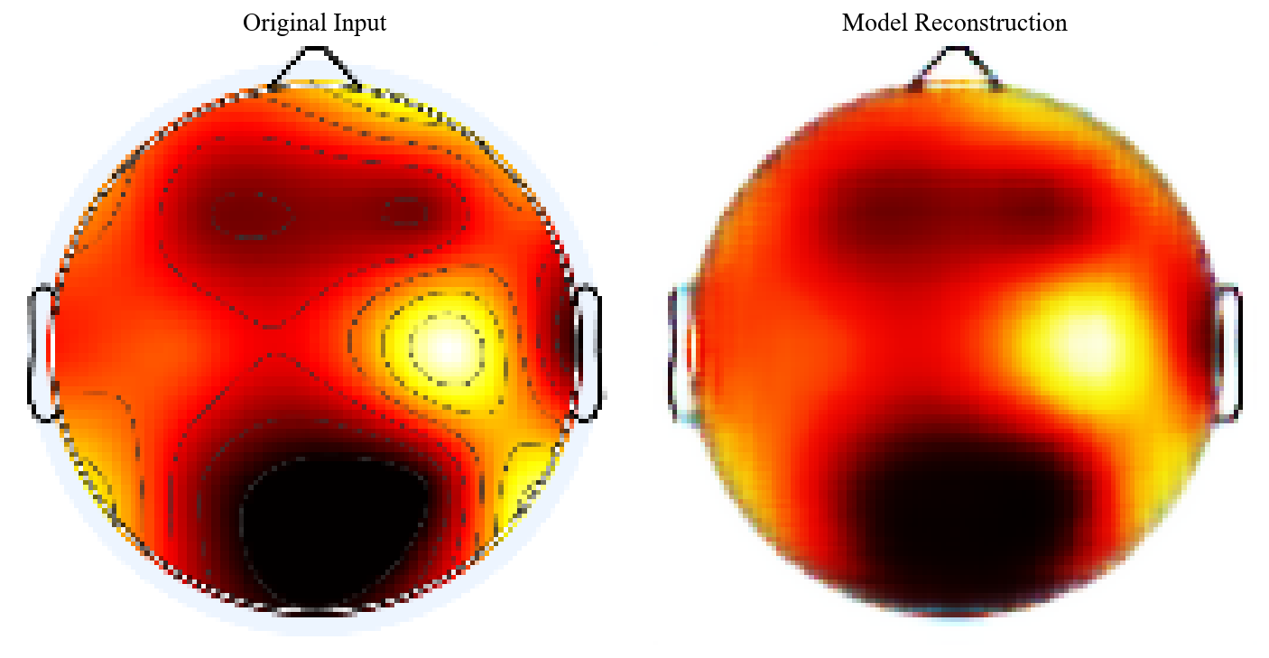
Figure 16. Reconstructed EEG topoplots output for respondent G after baseline removal
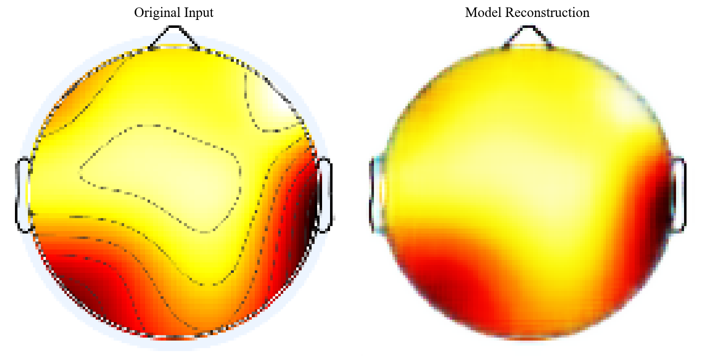
Figure 17. Reconstructed EEG topoplots output for respondent H after baseline removal
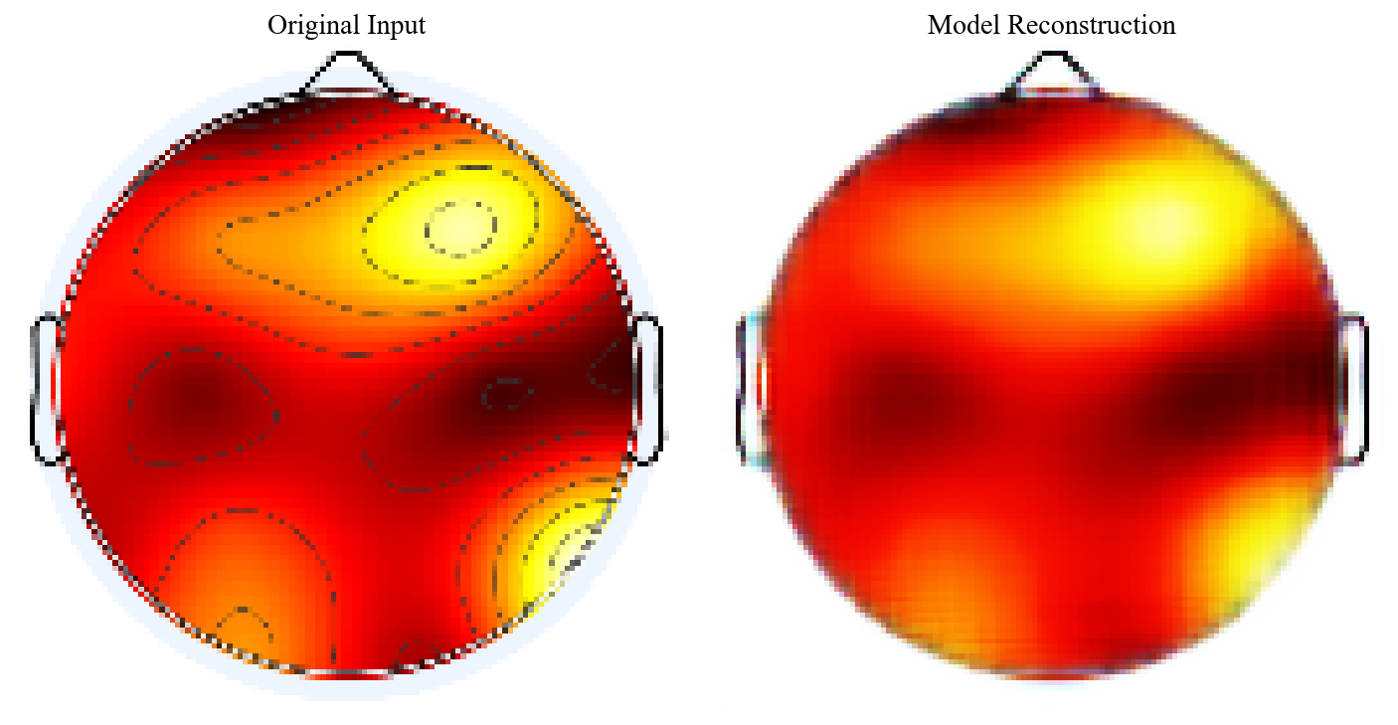
Figure 18. Reconstructed EEG topoplots output for respondent I after baseline removal
The reconstructive capabilities of the autoencoder are visualized in Figure 16 to Figure 18. Mirroring the efficacy observed in the Normal category, the model successfully filters out the baseline artifacts, ensuring that the output images strictly emphasize regions of potent neural activity while effectively silencing the background noise. Following this purification, the dataset undergoes the aggregation phase. Instead of relying on raw pixel averaging, we leverage a latent space approach to compute the mean representations, which yields a more comprehensive and structurally accurate visualization. The final synthesized pattern derived from this Risk-Fast cohort is presented in Figure 13.

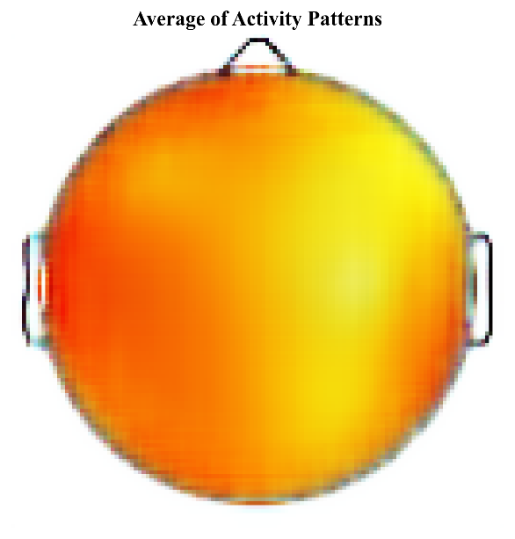
Figure 19. Average of activity patterns in at-risk fast category respondent
The averaged topography depicted in Figure 13 exposes a compelling neurophysiological anomaly: activity is not localized but is instead dispersed diffusely across the entire cortical surface. This pattern of excessive global activation—often referred to as cortical hyper-arousal—strongly suggests that the neural response is being modulated by intense emotional engagement rather than pure cognitive processing. Such findings resonate with the 'neural inefficiency' hypothesis in neuroscience, which posits that individuals with compromised impulse control or high anxiety must recruit significantly larger neural networks to achieve the same cognitive outcome as neurotypical peers [19]. In the context of this study, the presence of addiction-related terminology appears to trigger a reactive, emotionally charged state. Consequently, the rapid reaction times observed in this group should not be mistaken for cognitive efficiency; rather, they are likely driven by impulsivity [20], [21]. This visualization provides empirical evidence that At-Risk respondents are operating under a considerably heavier cognitive and emotional burden during the assessment.

  - At Risk – Slow Category Respondents
The remaining dataset focuses on 'At-Risk' respondents with delayed reaction times, a subset consisting of 167 topoplot images. Before attempting any reconstruction, it is critical to visually audit the raw inputs to grasp their irregularity. Figure 14 captures this baseline state. These samples expose the volatile nature of the signals in this group, offering a clear view of the chaotic fluctuations and high noise levels that the model is tasked with resolving.
J.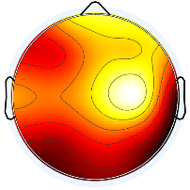K.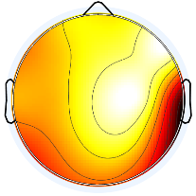L.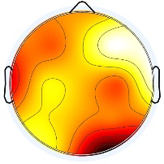
Figure 20. Examples of At-Risk category in slow responses
Visual inspection of Figure 14 uncovers a signal landscape defined by complex fluctuations and a predominantly dark intensity. However, a crucial distinction emerges when compared to the At-Risk Fast category: while the Fast group showed a uniform, global saturation, the Slow group exhibits a far more erratic spatial distribution. The patterns here are not consistent; instead, they display irregular variations in intensity across different respondents, although the overall signal amplitude remains noticeably higher (darker) than that of the Normal categories. Given this spatial incoherence, the subsequent model training phase was critical to suppress the noise and reconstruct the underlying topology. The quantitative performance of this process is tracked in the loss evaluation graph below.
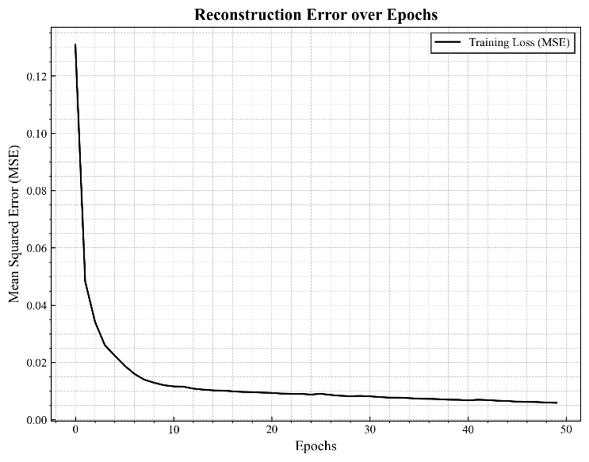
Figure 21. Reconstruction models error over epoch for Normal-Fast
The training metrics indicate that the loss function plateaued just above the 0.01 threshold (MSE > 0.01), preventing the deep convergence seen in the other groups. This slightly elevated error rate is indicative of the dataset's intrinsic heterogeneity; it reflects the unstable neural fluctuations that occur as 'Risk-Slow' respondents struggle to process the stimuli over a longer duration. Notwithstanding this statistical deviation, the qualitative results in Figure 21 demonstrate that the model remains highly effective. It successfully strips away the baseline artifacts, ensuring that the primary activity zones are clearly delineated from the background noise. With the signal thus purified, we proceeded to average the topoplots to map the group's collective cognitive focus. The resulting spatial distribution is visualized in Figure 22 to Figure 24.
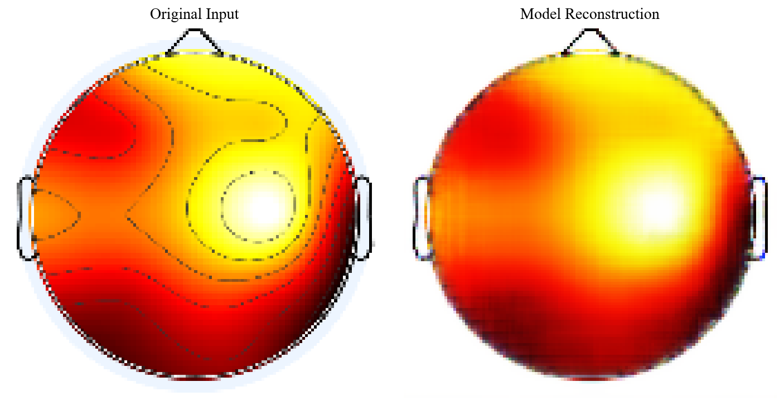
Figure 22. Reconstructed EEG topoplots output for respondent J after baseline removal
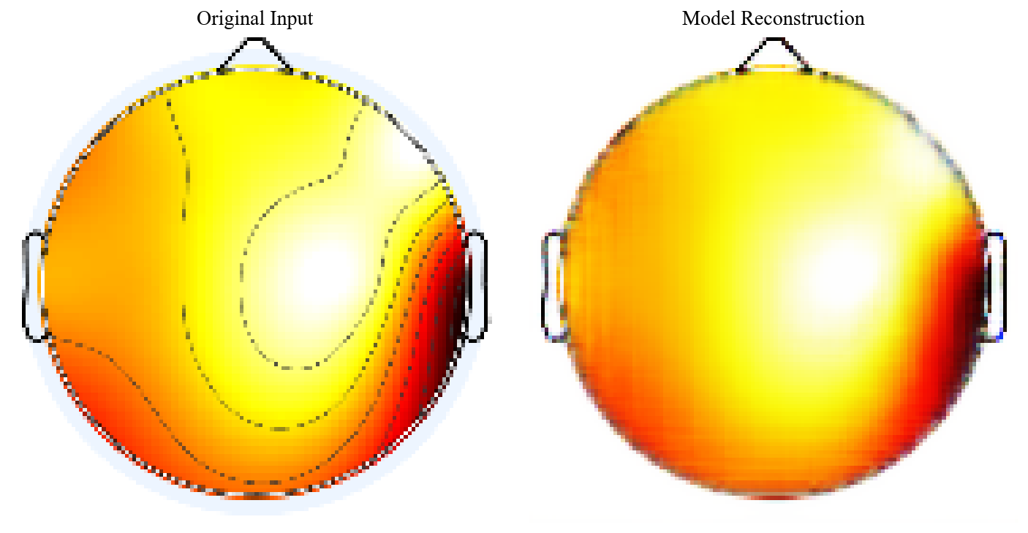
Figure 23. Reconstructed EEG topoplots output for respondent K after baseline removal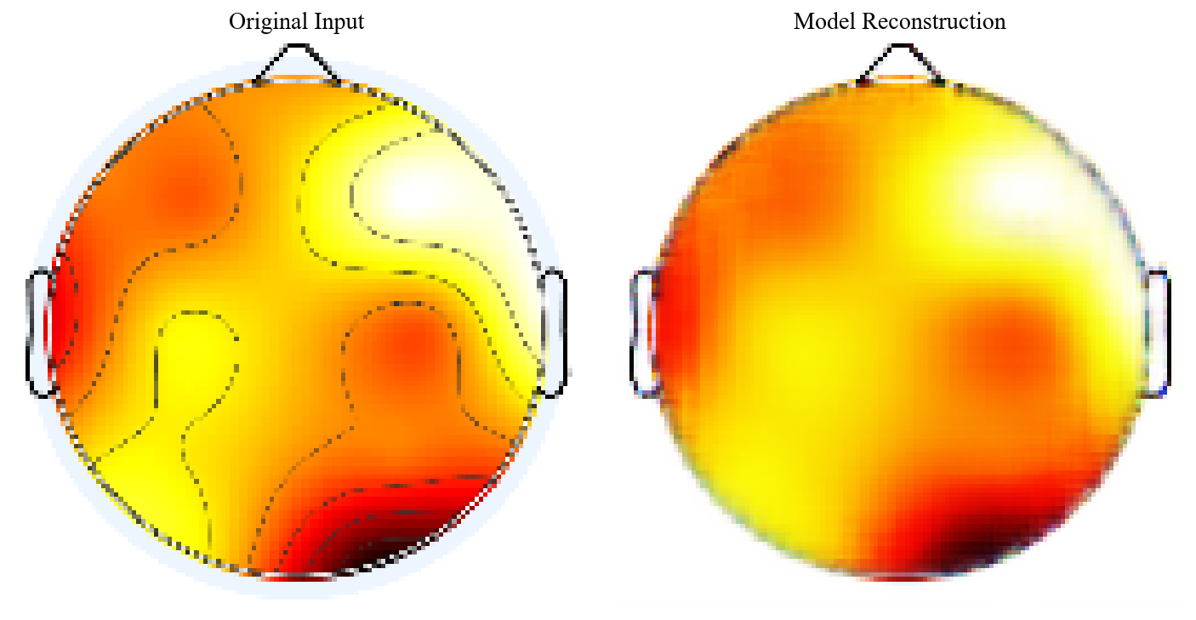
Figure 24. Reconstructed EEG topoplots output for respondent L after baseline removal.
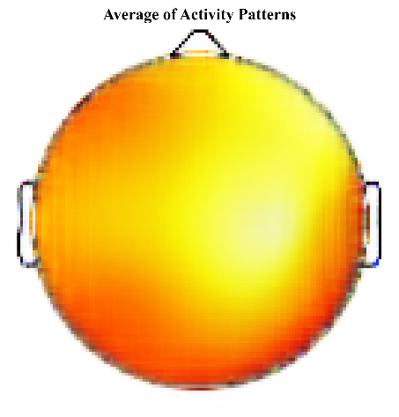
Figure 25. Average of activity patterns in at-risk slow category respondent
The averaged topography unveils a pronounced asymmetry in neural distribution. Activity is heavily concentrated in the posterior regions—specifically the Occipital and Temporal lobes—standing in stark contrast to the minimal engagement observed in the Frontal area. This pattern provides neurophysiological evidence supporting the 'Attentional Bias' framework often cited in addiction pathology. The heightened Occipital intensity suggests that respondents are visually fixated on the addiction-related cues, while the concurrent Temporal activation indicates the automatic retrieval of semantic or episodic memories associated with substance use [22]. Consequently, delayed reaction times can be interpreted as a failure of executive control: attentional resources are being disproportionately allocated to visual processing and memory recall, creating a bottleneck that hinders the Frontal lobe from executing a timely decision. Furthermore, this reduced frontal engagement aligns with existing studies showing that narcotic usage compromises the functional integrity of the prefrontal cortex [23].

Conclusion
The comparative analysis conducted across the respondent categories elucidates that reaction time—whether fast or slow—is not merely a temporal metric but a reflection of distinct underlying neural strategies. The study successfully mapped these differences, revealing that 'Fast' responses in risk groups are driven by impulsive hyper-arousal, whereas 'Slow' responses are characterized by cognitive hesitation and scattered spatial attention. From a methodological standpoint, the implementation of the Autoencoder architecture emerged as a pivotal advancement for EEG topography analysis. Unlike traditional filtering methods which often degrade signal integrity, the Autoencoder leverages latent space representations to intelligently distinguish between genuine neural activity and baseline artifacts [24].
This generative approach proves to be highly effective in "masking" the baseline, thereby producing reconstructed topoplots that are both structurally complete and free from noise. By synthesizing clean data from complex, noisy inputs, this model offers a robust solution for the challenges of signal averaging in neuroinformatics [25]. Consequently, this research validates the Autoencoder not only as a tool for noise reduction but as a comprehensive framework for generative image processing, capable of uncovering subtle neural patterns that are otherwise obscured in raw EEG datasets.
The heterogeneity observed in the results, particularly within the 'At-Risk' cohorts, opens fertile ground for novel investigative pathways. The current study highlights that neural responses to addiction cues are highly individualized; thus, future research should aim to decode this variability using more sophisticated architectures. There is a compelling opportunity to extend this work by integrating Variational Autoencoders (VAEs) or Generative Adversarial Networks (GANs) to model the probability distribution of these diverse responses more precisely. Furthermore, incorporating Explainable AI (XAI) techniques would be a critical next step to interpret why the model focuses on specific cortical areas, bridging the gap between "black box" deep learning and clinical interpretability in addiction psychiatry. Longitudinal studies could also be employed to track how these topographical patterns evolve over time, offering potential biomarkers for monitoring rehabilitation progress.

Acknowledgment
This research was conducted with funding from a competitive postgraduate research grant v.

References
[1] G. Placidi, L. Cinque, and M. Polsinelli, “Convolutional Neural Networks for Automatic Detection of Artifacts from Independent Components Represented in Scalp Topographies of EEG Signals,” Sep. 2020, doi: 10.1016/j.compbiomed.2021.104347.
[2] V. Janiukstyte et al., “Normative brain mapping using scalp EEG and potential clinical application,” Sci. Rep., vol. 13, no. 1, Dec. 2023, doi: 10.1038/s41598-023-39700-7.
[3] I. Wijayanto et al., “Unlocking Early Detection and Intervention Potential: Analyzing Visual Evoked Potentials in Adolescents/ Teenagers with Narcotics Abuse Tendencies from the TelUnisba Neuropsychology Electroencephalograph Dataset,” J. Electron. Electromed. Eng. Med. Informatics, vol. 6, no. 4, pp. 445–458, Oct. 2024, doi: 10.35882/jeeemi.v6i4.476.
[4] R. A. Clark, N. Nikolova, W. J. McGeown, and M. Macdonald, “Eigenvector alignment: Assessing functional network changes in amnestic mild cognitive impairment and Alzheimer’s disease,” PLoS One, vol. 15, no. 8 August, Aug. 2020, doi: 10.1371/journal.pone.0231294.
[5] T. Wen and Z. Zhang, “Deep Convolution Neural Network and Autoencoders-Based Unsupervised Feature Learning of EEG Signals,” IEEE Access, vol. 6, pp. 25399–25410, May 2018, doi: 10.1109/ACCESS.2018.2833746.
[6] M. Q. Pérez, S. L. Bernal, E. H. Prat, L. M. Del Campo, L. F. Maimó, and A. H. Celdrán, “EEG channel reconstruction using convolutional neural networks in limited BCIs: A proposed method for neuromarketing applications,” Appl. Soft Comput., vol. 181, Sep. 2025, doi: 10.1016/j.asoc.2025.113455.
[7] T. Hoffmann, “Latent space approaches to aggregate network data,” Mar. 2023, [Online]. Available: http://arxiv.org/abs/2303.08338
[8] I. Wijayanto, “TelUnisba Neuropsychology EEG Dataset (TUNDA),” 2024, Telkom University Dataverse. doi: 10.34820/FK2/GW8JIV.
[9] J. Masci, U. Meier, D. Cireşan, and J. Schmidhuber, “Stacked convolutional auto-encoders for hierarchical feature extraction,” Lect. Notes Comput. Sci. (including Subser. Lect. Notes Artif. Intell. Lect. Notes Bioinformatics), vol. 6791 LNCS, no. PART 1, pp. 52–59, 2011, doi: 10.1007/978-3-642-21735-7_7.
[10] R. Yamashita, M. Nishio, R. K. G. Do, and K. Togashi, “Convolutional neural networks: an overview and application in radiology,” Insights Imaging, vol. 9, no. 4, pp. 611–629, 2018, doi: 10.1007/s13244-018-0639-9.
[11] S. Albawi, T. A. M. Mohammed, and S. Alzawi, “Understanding of a Convolutional Neural Network,” Icet2017, pp. 1–6, 2017, doi: 10.1109/ICEngTechnol.2017.8308186.
[12] Y. Bengio, A. Courville, and P. Vincent, “Representation learning: A review and new perspectives,” IEEE Trans. Pattern Anal. Mach. Intell., vol. 35, no. 8, pp. 1798–1828, 2013, doi: 10.1109/TPAMI.2013.50.
[13] D. Berthelot, I. Goodfellow, C. Raffel, and A. Roy, “Understanding and improving interpolation in autoencoders via an adversarial regularizer,” 7th Int. Conf. Learn. Represent. ICLR 2019, 2019, doi: 10.48550/arXiv.1807.07543.
[14] E. M. Templeton, L. J. Chang, E. A. Reynolds, and M. D. Cone, “Fast response times signal social connection in conversation,” vol. 119, no. 4, 2022, doi: 10.1073/pnas.2116915119/-/DCSupplemental.Published.
[15] T. Emsawas, T. Kimura, S. Ogura, H. Morita, and E. Abdullajon, “Identifying english proficiency by frontal theta activity during english learning,” Discov. Educ., 2025, doi: 10.1007/s44217-025-00517-3.
[16] A. Valentin, R. Selway, G. Alarco, M. E. Lacruz, and J. J. Garcı, “Frontal and temporal functional connections of the living human brain,” vol. 26, no. March, pp. 1357–1370, 2007, doi: 10.1111/j.1460-9568.2007.05730.x.
[17] M. Kotas, M. Piela, and S. Contreras-Ortiz, “Modified Spatio-Temporal Matched Filtering for Brain Responses Classification,” IEEE Trans. Human-Machine Syst., vol. 52, pp. 1–10, Jan. 2022, doi: 10.1109/THMS.2022.3168421.
[18] X. Liang, F. Xiao, Y. Lei, H. Li, and Q. Chen, “N400/frontal negativity reveals the controlled processes of taxonomic and thematic relationships in semantic priming for artifacts,” Psychophysiology, vol. 57, no. 2, Feb. 2020, doi: 10.1111/psyp.13486.
[19] A. C. Neubauer and A. Fink, “Neuroscience and Biobehavioral Reviews Intelligence and neural efficiency,” vol. 33, pp. 1004–1023, 2009, doi: 10.1016/j.neubiorev.2009.04.001.
[20] J. Zhang, L. Yang, Y. Zhang, H. Su, Y. Zhang, and Y. Yang, “Updating Emotional Stimuli in Heroin Abstainers’ Working Memory: An Event-Related Potential Investigation,” Subst. Use Misuse, vol. 56, no. 6, pp. 801–807, 2021, doi: 10.1080/10826084.2021.1899223.
[21] G. F. Koob and N. D. Volkow, “Neurobiology of addiction : a neurocircuitry analysis,” The Lancet Psychiatry, vol. 3, no. 8, pp. 760–773, 2016, doi: 10.1016/S2215-0366(16)00104-8.
[22] Y. Yalachkov, J. Kaiser, and M. J. Naumer, “Sensory and motor aspects of addiction,” vol. 207, pp. 215–222, 2010, doi: 10.1016/j.bbr.2009.09.015.
[23] A. O. Ceceli and C. W. Bradberry, “The neurobiology of drug addiction : cross-species insights into the dysfunction and recovery of the prefrontal cortex,” no. August, 2021, doi: 10.1038/s41386-021-01153-9.
[24] T. Zhao et al., “NeuroImage VAEEG : Variational auto-encoder for extracting EEG representation,” Neuroimage, vol. 304, no. July, p. 120946, 2024, doi: 10.1016/j.neuroimage.2024.120946.
[25] M. Y. Sikkandar et al., “Optimization Driven Variational Autoencoder GAN for Artifact Reduction in EEG Signals for Improved Neurological Disorder and Disability Assessment,” no. 1, pp. 10–14, 2025, doi: 10.2478/msr-2025-0002.

